MVL-HF0824M-10MP
1/1.8" 8mm 10MP FA LENS

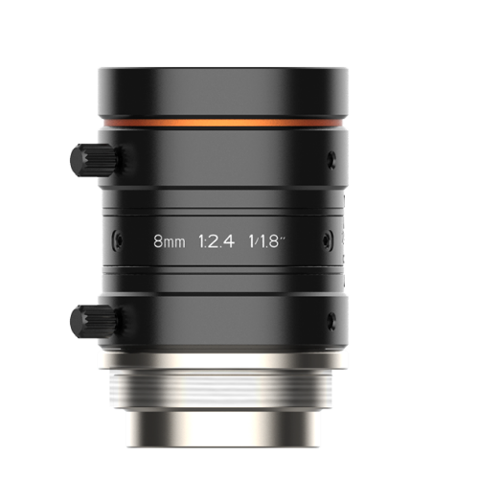

HF-P series FA Lens are optimized for machine vision light sources and sensor, with high resolution, excellent image quality, high transmittance and good stability. Featured with fixed focal length, manual aperture and compact size, it is suitable for machine vision industry applications and ideal for industrial cameras.

Key Features
- Ultra high resolution and consistency of image clarity
- Bigger aperture, lower distortion and higher relative illumination rate
- Achromatic optical system design, Better imaging performance with color camera
- Excellent vibration resistance performance, optical axis shifting within pixel level
- Good stability at high and low temperature
- Multilayer and broadband coating design, compatible with visible and near-infrared applications

Note：The above curves are the simulate results based on F2.4, β=-0.019, WD=400 mm.
MTF
Relative Illumination
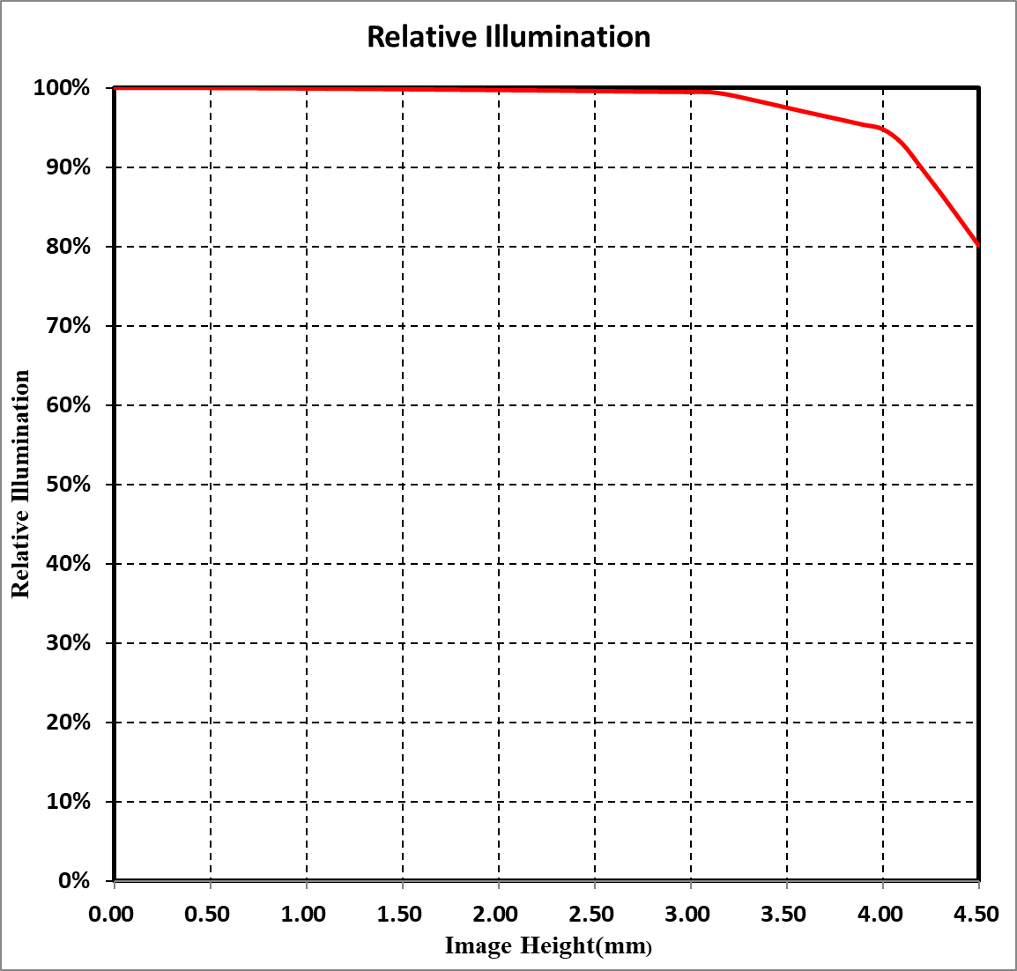
Distortion
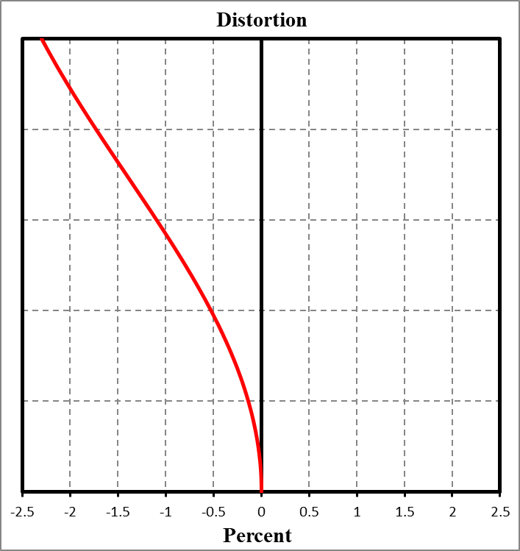
Dimension
Specification
Model  Parameter | MVL-HF0824M-10MP
Model  Parameter | Fixed focal length, Manual iris, 10MP, FA Lens
Performance
Focal length | 8 mm
F-number | F2.4 to F16
Image size | Ø9 mm (1/1.8")
Distortion | –0.67%
Minimum object distance | 0.1 m
Field of view | D (8.96 mm): 58.81°  H (7.38 mm): 49.56°  V (4.92 mm): 34.04°
Mechanical
Iris control | Manual
Focus control | Manual
Filter thread | M27 × 0.5
Mount | C-mount
Flange back length | 17.526 mm
Dimension | Ø29 mm × 34.8 mm (Ø1.1" x 1.4")
Weight | 70.9 g (0.2 lb.)
Temperature | –10°C to 50°C (14 °F to 122 °F)
General
Certification | RoHS 2.0

Field of View
Extension (mm) | Working  Distance  (mm) |  | Magnification | Field of View (mm)
Extension (mm) |  |  | Magnification | 1/1.8" |  | 1/2"
Extension (mm) |  |  | Magnification | H(7.38mm) | V(4.92mm) | H(6.22mm) | V(4.67mm)
2 | near | 12.68 | –0.300 | 24.17 | 15.65 | 20.06 | 14.82
2 | far | 20.12 | –0.240 | 31.12 | 20.21 | 25.87 | 17.15
1 | near | 28.6 | –0.190 | 39.17 | 25.54 | 32.63 | 24.20
1 | far | 52.65 | –0.120 | 61.37 | 40.19 | 51.25 | 38.09
0 | 100 |  | –0.070 | 106.09 | 69.80 | 88.83 | 66.18
0 | 150 |  | –0.048 | 152.48 | 100.50 | 127.79 | 95.30
0 | 200 |  | –0.037 | 198.83 | 131.19 | 166.74 | 124.40
0 | 250 |  | –0.030 | 245.17 | 161.87 | 205.67 | 153.50
0 | 300 |  | –0.025 | 291.50 | 192.54 | 244.60 | 182.60
0 | 350 |  | –0.022 | 337.82 | 223.21 | 283.52 | 211.69
0 | 400 |  | –0.019 | 384.17 | 253.90 | 322.46 | 240.80
0 | 450 |  | –0.017 | 430.46 | 284.55 | 361.36 | 269.87
0 | 500 |  | –0.015 | 476.78 | 315.22 | 400.28 | 298.96
0 | 550 |  | –0.014 | 523.09 | 345.88 | 439.19 | 328.04
0 | 600 |  | –0.013 | 569.40 | 376.55 | 478.10 | 357.13
0 | 650 |  | –0.012 | 615.72 | 407.22 | 517.02 | 386.22
0 | 700 |  | –0.011 | 662.02 | 437.87 | 555.92 | 415.30
0 | 800 |  | –0.010 | 754.64 | 499.20 | 633.75 | 473.47
0 | 900 |  | –0.009 | 847.28 | 560.54 | 711.58 | 531.65
0 | 1000 |  | –0.008 | 939.91 | 621.87 | 789.42 | 589.82

